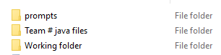
2025 Program Logistics
Every team will receive a flash drive with three folders similar to the image to the right.
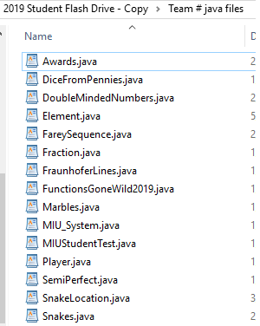
The prompts folder contains an electronic copy of the prompts in both Word and pdf format. You will also receive a hard copy of the prompts.

The other two folders contain the java files you will edit. The image to the left is the Team# java files from 2019. (This year the folder is simply named Team #, where # is replaced by your number). These are the files that MUST compile!
This is the folder I will collect and grade.
- Once again, all files in this folder must compile.
- All provided files must exist in the folder. Even the files that are not modified must remain!
- Any helper Class you create must be included
- Any added files must compile as java files.
This implies no .class or word files or ….
If just one file does not compile, you contest score will be zero.

The “Working Folder” folder contains the same java files as the Team # folder and includes the jUnit test files for those interested in using them.
- I should note that all given java files have been hard coded to pass the student tester
- More information on Junit is provided on the next page.

I would suggest working on the files in the Working folder and when you are happy with the modification to a specific java file, move it to the Team # folder.

For example, suppose you are Team 09. I would be working on files in the Working folder. After your team has completed (or partially completed) a problem such as DoubleMindedNumbers, then I would move the new, improve version of DoubleMindedNumbers to the Team 09 folder. I would do this for all problems your team attempts. I would do this for ALL problems your team completes.

- It is possible to earn partial credit on each programming problem. You may earn points for completing just one method in a problem. You may even earn points for partially complete a method that handles most cases.

Here is a screen capture from a previous contest of BlueJ with the jUnit included:

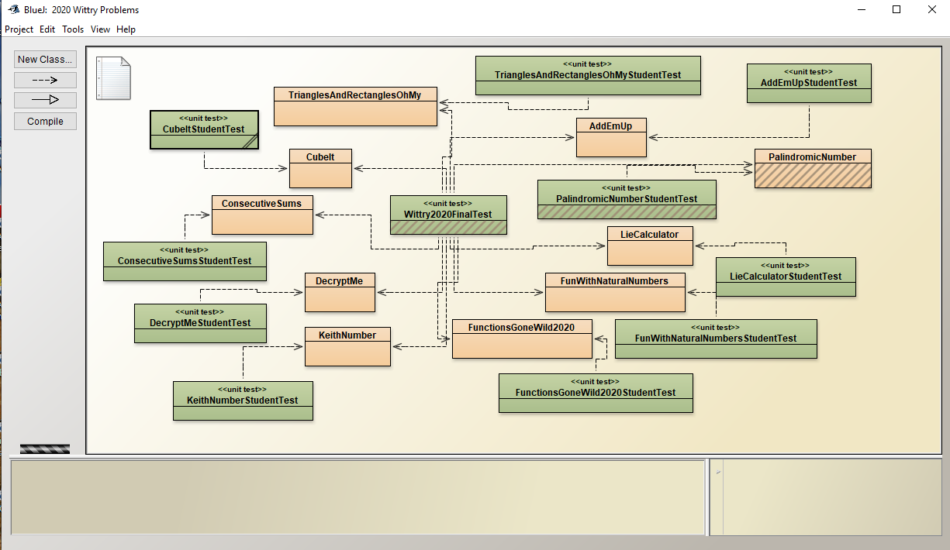

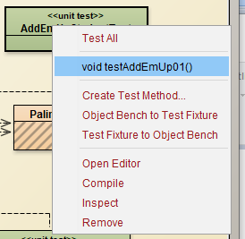
To use the student tester, you would right click on the green box (e.g., AddEmUpStudentTest} and the box to the right appears. You can select either TestAll or void testAddEmUp01() to get the results of your code for the data in this test. Realize the test used to grade you solution will have several different test cases evaluating the solution for the different test cases.

I admit, I do not know how to use the Junit test in other IDEs. I know it works in BlueJ. And it is not critical to your success in the contest. The intent of these test is to give you a easy way to test your solution for the given test values in the prompts.

One final note: Your program may not include any package commands. While they may work in your IDE, They will cause your code to not compile in Stipulator.

Once again, I hope this helps and does not cause more confusion

